Smartho-Windows SDK Integration Documentation

SDK Integration Documentation

1.1 Environment configuration
Windows version: Windows 10 and above.
System type: 64-bit operating system, x64-based processor.

1.2 Import SDK
1.2.1 Place the algorithm files in the SDK of “libfftw3-3.dll, libfftw3-3.lib, MinttiAlgo.dll, MinttiAlgo.lib” in the "bin\x64\Debug" directory of the startup project.

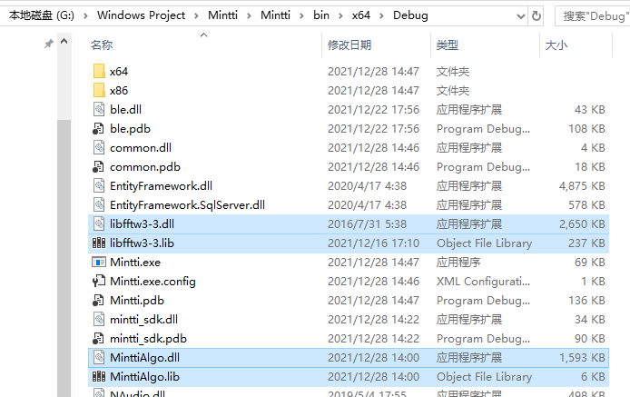
1.2.2 Reference the NuGet package of Microsoft.Windows.SDK.Contracts.

1.2.3 Import Bluetooth SDK

Open Visual Studio, right-click References under the project -> Add Reference -> Browse, click the Browse button to find the location of mintti_sdk.dll, and add it.
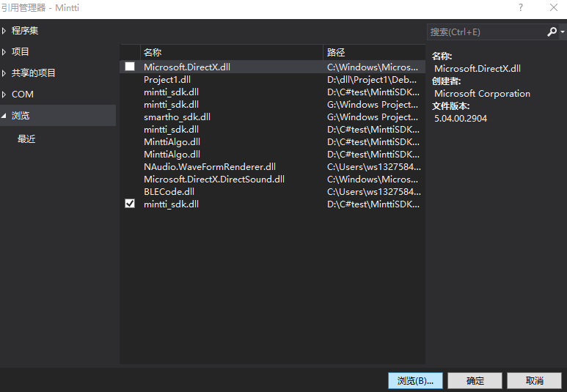

Description of the API interface of the device Bluetooth communication module

2.1 Description of the function
This module provides the ability for the application to communicate with the electronic stethoscope, and the functions of device Bluetooth scanning, connection, connection status monitoring and data communication. The developer only needs to call the corresponding API interface to realize the interaction with the electronic stethoscope device.

2.2 Description of the MinttiBle class
MinttiBle is used to interact with the stethoscope. This class adopts the singleton mode, and the instance of this class can be obtained through MinttiBle. GetInstance.

2.2.1 Subscription

The Bluetooth SDK communicates Bluetooth scan status, connection status, device information, etc. by means of user subscription events. In order to use the SDK normally, please subscribe to the following events:

1·MessageChanged prompts a message event: the delegate type of the event receives three parameters void MessageChangedEvent(MsgType type, string message, byte[] data = null);
public enum MsgType
{
NotifyTxt, ConnectStatus
}

MsgType is an enumeration type that provides two enumeration variables, NotifyTxt and ConnectStatus. NotifyTet represents some notifications during Bluetooth operation, and ConnectStatus represents notifications of connection status. “Message” indicates the content of the notification; “data” indicates the data of the notification. This parameter is defaulted as empty.

2·DeviceWatcherChanged Bluetooth search event: the delegate type of this event will take over a parameter of DeviceInfo type, void DeviceWatcherChangedEvent(DeviceInfo deviceInfo); this parameter type has two properties only: name, and mac. “Name” represents the Bluetooth name, “mac” represents the Bluetooth address. Subscribers will be notified of this information at once when a device is scanned.

3·DataCallback measurement data: by sending data to subscribers through this event, the delegate type of this event receives a short[] to carry the data, void DataCallbackEvent(short[] data);
4·SpkDataCallback Voice data is sent to subscribers through this event, and the delegate type of this event receives a short[] to carry the data.void SpkDataCallbackEvent(short[] data);
5·MicDataCallback Microphone data is sent to subscribers through this event, and the delegate type of this event receives a short[] to carry the data. void MicDataCallbackEvent(short[] data);

6·ModelSwitchback mode switching: When the auscultation mode is switched, a notification will be sent to the subscriber through this event. The delegate type of the event receives an EchoMode enumeration type table to represent the current mode “void ModelSwitchbackEvent(EchoMode mode)”;
public enum EchoMode
{
MODE_BELL_ECHO,// heart sound
MODE_DIAPHRAGM_ECHO// lung sound
}

7·PowerCallback power notification event: When the power of the stethoscope changes, a notification will be sent to the subscriber through this event. This delegate type of the event receives an int type parameter to represent the current power: “void PowerCallbackEvent(int power)”;

8·HeartRateCallback heart rate notification event: The heart rate calculated during the measurement process is sent to the subscriber through this event. The delegate type of the event receives an int type parameter to represent the current heart rate: void HeartRateCallbackEvent(int hr);
9·DataLoseCallback Data loss event, when the Bluetooth signal is weak, data loss will occur, and the data loss will be sent to the subscriber through this event, void DataLoseCallbackEvent();
10·PressTooBigCallback Press too much event, when there is too much pressure on the bottom of the device, it will be sent to the subscriber through this event,void PressTooBigCallbackEvent();

2.2.2 Bluetooth Connection

2.2.2.1 Scanning the device
Start Bluetooth scanning with "StartBleDeviceWatcher()" and stop Bluetooth scanning with "StopBleDeviceWatcher()". The results of the scan are notified to subscribers via DeviceWatcherChanged.

2.2.2.2 Connecting the stethoscope device
MinttiBle provides two overloaded connection methods:
Connect(BluetoothLEDevice Device)
ConnectByMac(string mac)
The connection result will be notified to subscribers via MessageChanged.

2.2.3 Auscultation data collection
The auscultation data is collected through the following two modes
1. BELL mode.
2. DIAPHRAGM mode.

2.2.3.1 Mode Switch

The SDK provides the SwitchModelAsync (EchoMode echoMode) interface for mode switching. For the description of EchoMode, please find item 4 in 2.2.1.

When the mode changes, it is automatically notified via ModelSwitchback.

2.2.3.2 Start measuring
Measured by the StartMeasure() method, the measurement data is notified by the DataCallback event, and the heart rate information is notified by the HeartRateCallback event.

2.2.3.3 End measurement
End the measurement with StopMeasure().

2.2.3.4 Read battery
Read the power of the device through Task<string> GetPowerAsync(), encapsulate the power information into Task<string> and return back.

When the battery level changes, it will automatically notify via PowerCallback.

2.2.3.5 Disconnect
Disconnect the Bluetooth connection via Dispose().

New in 2.0.6
Task<bool> GetBleEnableAsync(): Returns true if the computer has a Bluetooth module, otherwise it does not.
Task<bool> IsOpenBleAsync(): Returns true to indicate that Bluetooth is on, otherwise it is off.

